Project 2 Report
CS7646
Author: Saad Rasool
srasool7@gatech.edu
- Plots Attachments:
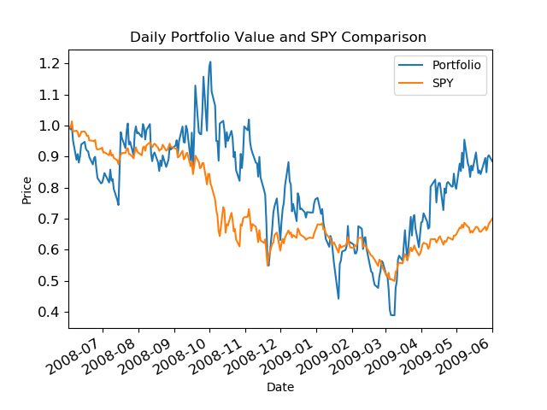

- Reference lists
- https://learning.oreilly.com/library/view/python-for-finance/9781491945360/ch11.html#_portfolio_optimization
- https://docs.scipy.org/doc/scipy/reference/generated/scipy.optimize.minimize.html
- https://lucylabs.gatech.edu/ml4t/spring2023/project-2/

